PH126 Starting Logic Lecture 6
Lecturer: s.butterfill@warwick.ac.uk

Wrong proofs
Step 7 of this proof is wrong. Why?
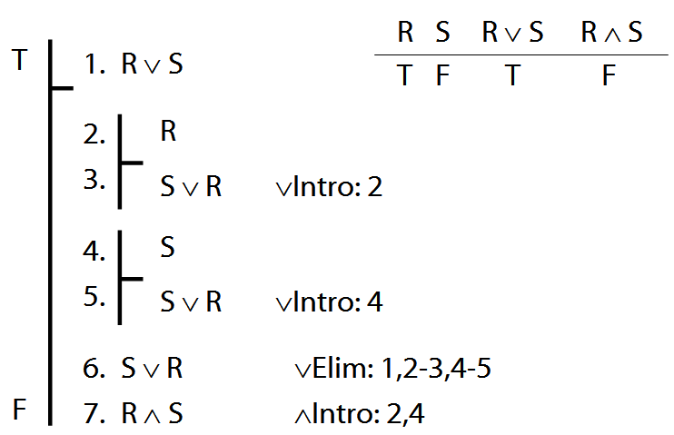

Which step of this proof is wrong? Why?
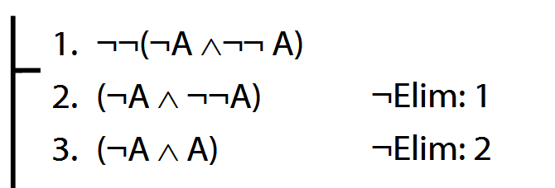

Scope
In P∧ (Q∨R), the scope of ∧ is P∧ (Q∨R)
In P∧ (Q∨R), the scope of ∨ is (Q∨R)
In (P∧Q) ∨R, the scope of ∧ is (P∧Q)
In (P∧Q) ∨R, the scope of ∨ is (P∧Q) ∨R
The scope of a connective is the smallest constituent expression which contains that connective.
The Syntax of FOL
We define what counts as a sentence of FOL using rules. E.g.:
3. P, Q, R, … are sentences
4. If * is a sentence, then ¬* is a sentence
1. If * and # are sentences, then so is(* ∧ #)
2. If * and # are sentences, then so is (* ∨ #)
So:
a. P is a sentence // rule 3
b. ¬P is a sentence // rule 4, a
c. ( ¬P ∧ Q ) is a sentence // rule 1, b, a
Notes: (1) There is no structural ambiguity in FOL because these rules are formulated to ensure that for any FOL sentence, there is exactly one way of constructing it. (2) We used the notion of a sentence in the rules that define what a sentence is.

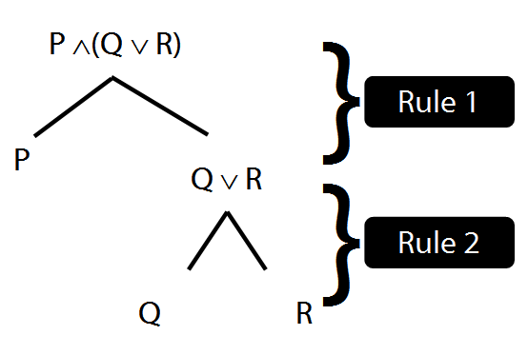
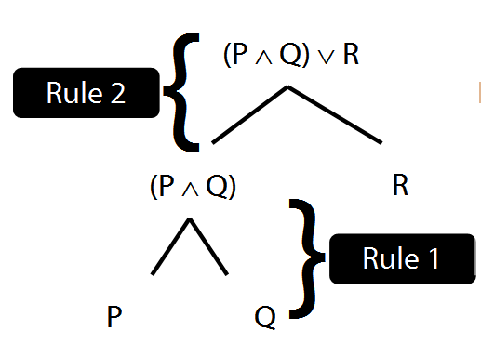
¬Intro proof example
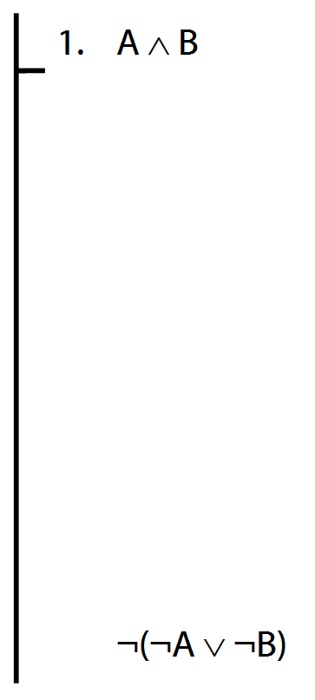

Exercises 03
For your fourth seminar
Not for fast groups

4.15–18 (truth tables)
5.1–6 (inference patterns)
*5.18 (counterexample)
6.2–6 (proofs)
6.7, 6.9–10, *6.11–12 (proofs)
Short of time? Skip the exercises marked *

